Navigation Audit Reporting Module
A Quick Guide

1. Navigation Audit Reports

These reports will display the data related to the Navigational Audit. There are 13 reports in this module divided into 4 sections.
To Navigate to this module login into BI instance using the below url.
http://192.168.166.202:9704/analytics/saw.dll?bieehome&startPage=1

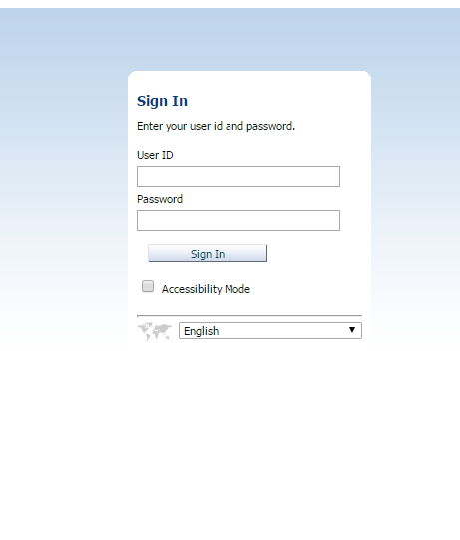

Enter the below Credentials
User ID : weblogic
Password : Welcome1

Once Logged in then navigate to the dashboards and select Corporate Dashboard

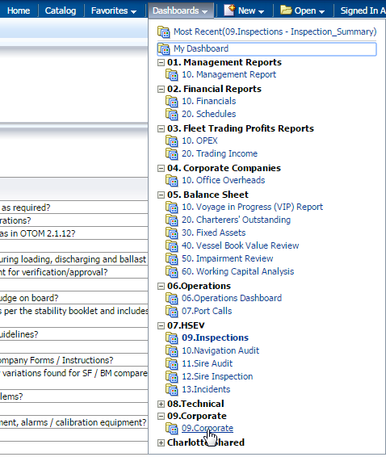

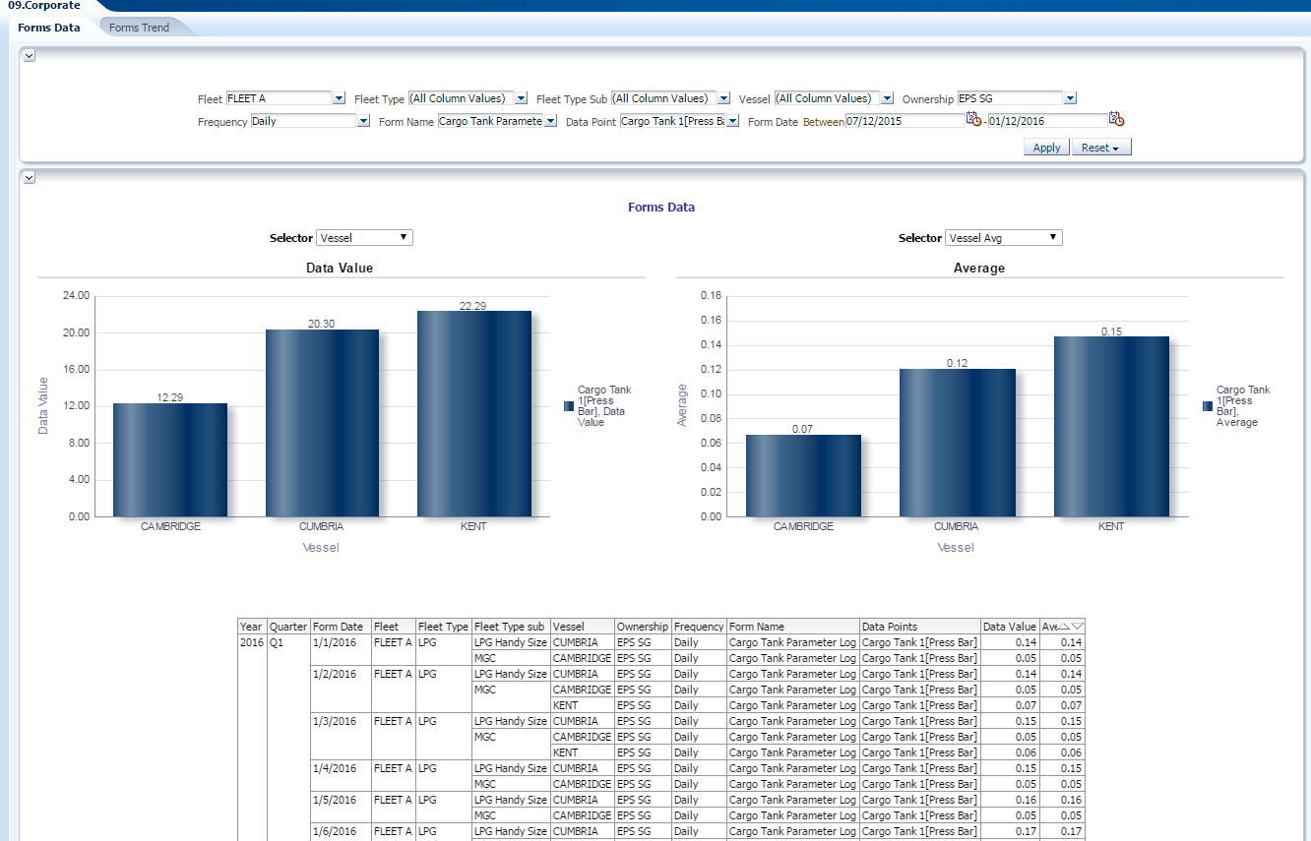

- There are 2 dashboards for the Corporate dashboards.
    - Forms Data : This provides the tabular and graphical representation of the data for the selected data points by fleet,vessel and date filters etc.
    - Forms Trend : This provides the tabular and graphical representation of the data for the selected data points by fleet,vessel and date filters etc.This Dashboard provides the flexibility to view the trend of a particular data point out of the selected data points.

Parameters for the Forms Data Dashboard:
- Fleet : FLEET A,FLEET B,FLEET C
- Fleet Type : Type of fleet (i.e., Tankers ,chemical etc)
- Fleet type sub : Fleet sub type like AFRAMAX etc
- Vessel : Vessel Name
- Owner ship : Ownership type as EPS-SG or EPS-UK
- Frequency : This enables the users to select the type of forms like Daily,Monthly etc
- Data Point: : The Data Points in the forms for which the value needs to be displated in the report.
- From Date : Date filters to determine the time period to fetch the data.

Parameters for the Forms Trend Dashboard:
- Fleet : FLEET A,FLEET B,FLEET C
- Fleet Type : Type of fleet (i.e., Tankers ,chemical etc)
- Fleet type sub : Fleet sub type like AFRAMAX etc
- Vessel : Vessel Name
- Owner ship : Ownership type as EPS-SG or EPS-UK
- Frequency : This enables the users to select the type of forms like Daily,Monthly etc
- Data Point: : The Data Points in the forms for which the value needs to be displated in the report.
- Data point Series : The data points for the trend series.
- From Date : Date filters to determine the time period to fetch the data.

- Forms Data Dasboard

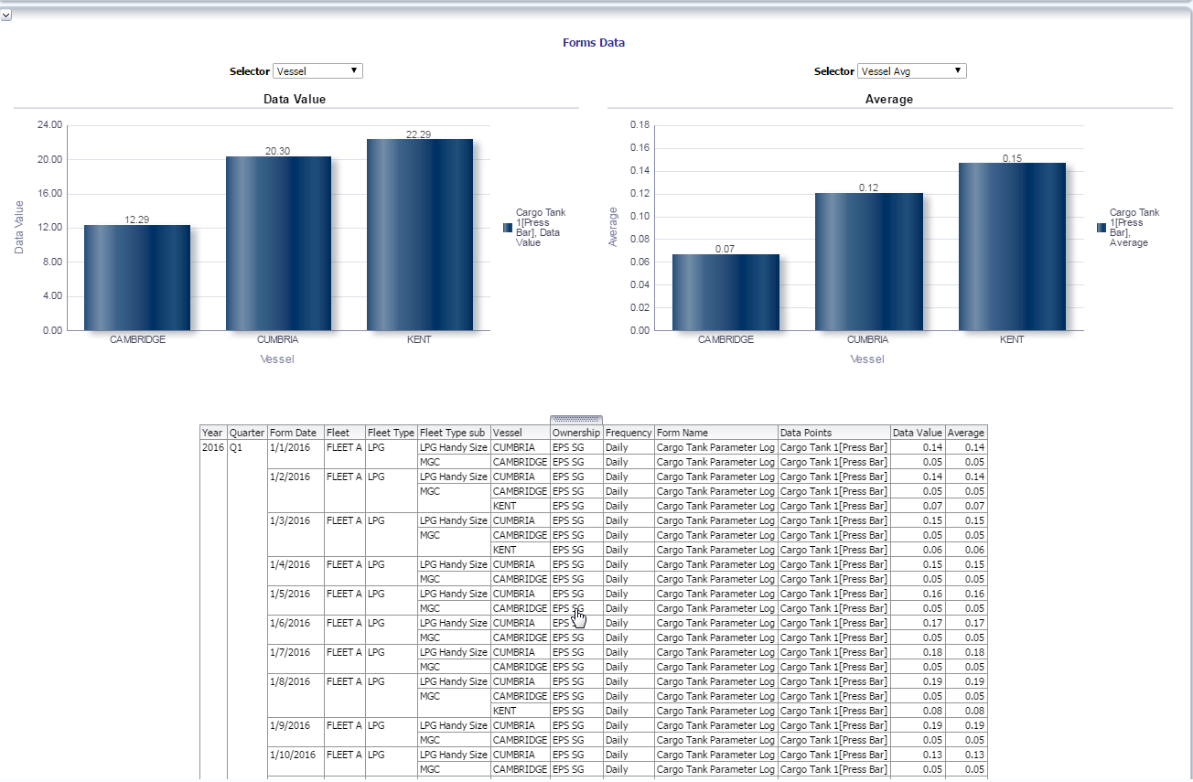

- Forms Trend Dash board

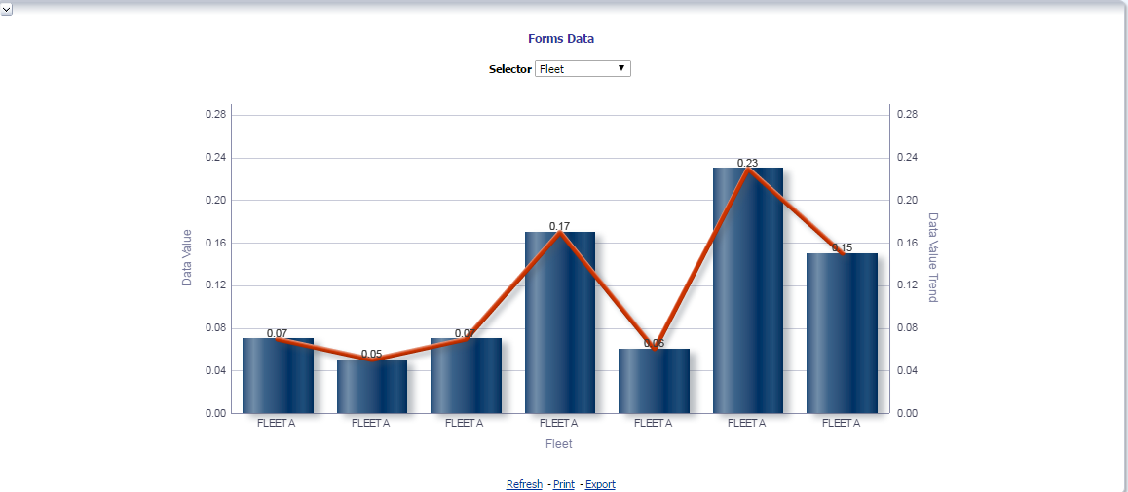

All these graphs can be viewed either by fleet wise,Fleet type Wise,Vessel Wise,Month Wise,quarter Wise and year wise by selecting the drop down.

